LOGOS – Delete the red copy in left column.
Insert your system logo

FOR IMMEDIATE RELEASE

Insert date, city, state

OHIO LOVES TRANSIT WEEK 2023

Transit is Essential | We Move People

Every segment of Ohio – businesses, communities, individuals and families – benefit from public transportation, an essential service that enhances economic development, insures sustainable lifestyles and a higher quality of life.
​
(Insert system name) provides over (insert number of trips) each year, helping to create and maintain jobs that are essential in keeping our communities strong. We connect friends and neighbors to jobs, schools, medical appointments and much more. Whether delivering groceries or providing a ride to get a vaccine…we are a lifeline for our community

We are a vital link for people with disabilities, providing rides to work,
job training programs, medical appointments and adult day care facilities.

We continue to meet the daily mobility needs of Ohio’s growing senior population as well as keeping up with the capital need to move workers, students and those without access to their own vehicles.

Our agency works to ensure all citizens have access to the transportation services they need to remain an active part of the community.

Transit drives our economy, with statistics showing that every $1 invested in public transit generates $4 in economic return. Whether getting to area shopping centers, local airports, libraries, parks, bike trails, or countless other destinations—transit will get you there

Ohio loves transit and Ohio needs transit… now, more than ever.

(insert quote from System Leadership)

These are just a few of the reasons why Ohio’s lawmakers are committed to continuing to support public transit. From February 5 through 11, (insert system name) will celebrate our elected officials and stakeholders as well as our communities and riders during Ohio Loves Transit Week.

The sixth annual Ohio Loves Transit Week will include activities with transit customers all week, peaking on Ohio Loves Transit Day, Tuesday, February 7, 2023.

(add specific details for your system OLT promotions and activities below)

During the week, we will also ask riders to share why they support public transit and why our state and federal leaders should too.

Ohio Loves Transit Week is hosted by our partner, the Ohio Public Transit Association (OPTA).

OPTA is the primary advocate for public transportation in Ohio. Now over 500 members strong from 67 transit agencies across the state, the association provides leadership, resources, training, support, technical assistance, media outreach, public engagement, and governmental relations services to public and private transit agencies.

(insert contact and web address below)
Contact:
System
Contact Name
Phone | Email

Website

###

-
-
-
-
-
-
-
-
-
-
-
-
-
-
-
-
-
-
-
-
-
-
-
-
-
-
-
-
-
-
-
-
-
-
-
-
-
-
-
-
-
-
-
-
-
- Message continued from page one.

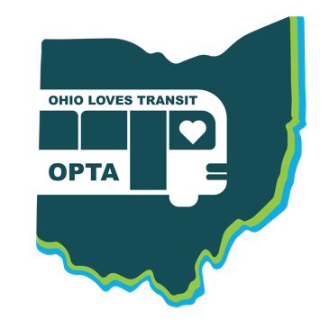
Ohio Loves Transit
in partnership with:

Delete this copy and insert your logo here.
