Type your message here.

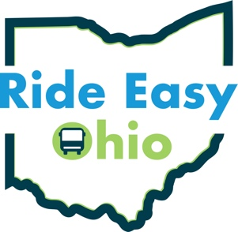
Ride Easy Ohio
in partnership with:

Delete this copy and insert your logo here.
